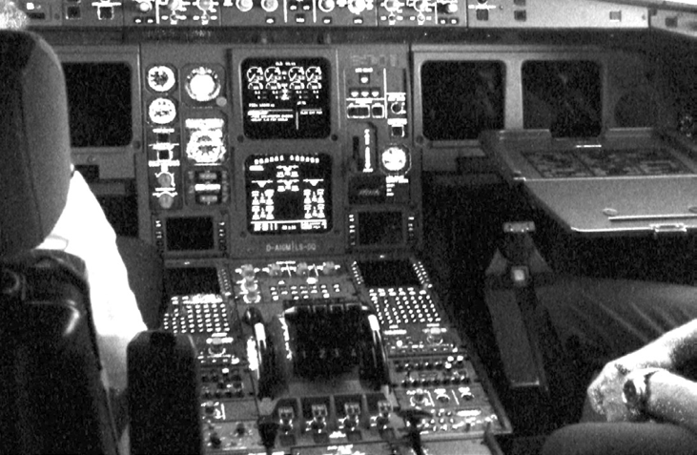

**ASLR**

***Objective: In this lab you view the Linux kernel’s implementation of ASLR in action.***

1. Verify the current state of ASLR in your Linux VM. The options are explained in (Documentation/sysctl/kernel.txt), 2= Full randomization.



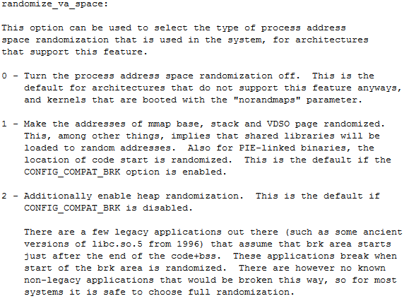

1. To demonstrate the effectiveness of ASLR on user mode applications execute the following command and observe the memory values.

cat /proc/self/maps | egrep ‘(heap|stack’)

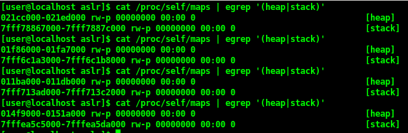

1. Run this command 4 more times.
2. Based on what we have learned, how does ASLR affect modern exploitation?
3. Is this a Band-Aid solution? What about KASLR?